**Scenario: Launch expired_page**

**Step: Launch "expired_page" WebPage - PASS**

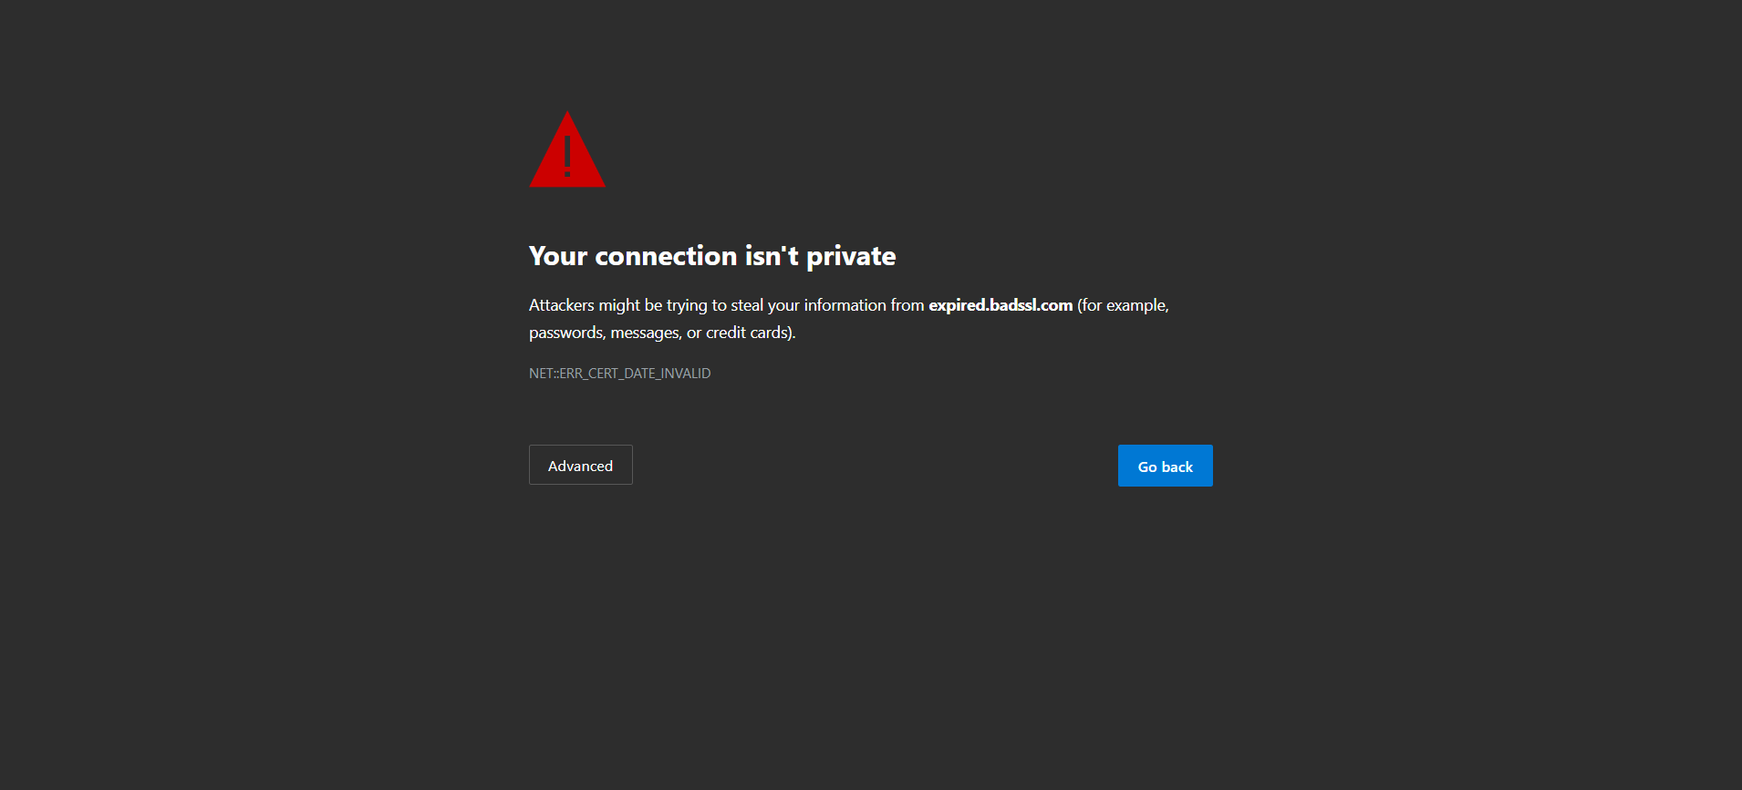

**Execution Summary:  
Total Steps: 1  
Passed: 1  
Failed: 0**